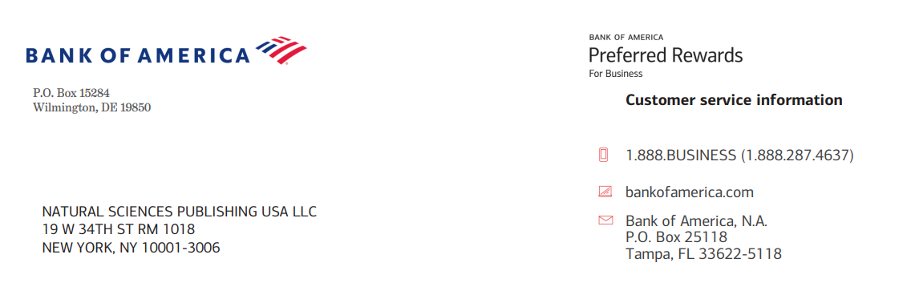
Invoice No. 062426

Prog. Frac. Diff. Appl.
https://www.naturalspublishing.com/

Psychological factors influencing administrative decision-making among educational leaders: A cognitive psychology perspective

Falah Dhuwaihi Al-Swairi Al-Ajmi

JSAP-451315315307222601A  15 August 2026 | Total Charge in US Dollars $2100.00  Discount 30%  Total Charge $1050.00.00

For payment, please use Bank transfer to:
 | Falah Dhuwaihi Al-Swairi Al-Ajmi
Bank Name | Bank of America
Bank Branch | 1293 Broadway, NYS-149-01-01, New York, 10001
NSP Address | 19 W 34th St. RM 1018, New York, NY 10001-3006
SWIFT Code | BOFAUS3N
Account Number | 483052729147
Wire routing number | 026009593
E-mail | nsp@naturalspublishing.com
Telephone | +1 (646)556-1606
